Sleepy Garden Collages

This activity brings together children’s learning from the programme in planning out a ‘sleep garden’, a design for a garden that helps to promote sleep. Children can use elements such as images, information from historical plant guides, medical manuals, local maps, recipe books, and craft materials to make their plan. Children will create collages on large pieces of A3 paper. These can combine all the elements a family like the Radclyffes of Ordsall Hall would need to sleep well with aspects that can help us sleep today. This can incorporate the need for time spent outside and in nature, sensory prompts to relaxation, spaces for exercise, areas of calm, and the growing of ingredients and materials. The gardens can be labelled/annotated with pens or using collaged labels.

Through these collages, children can consolidate their learning from Sleeping Well and create gardens which draw upon the areas covered. Ask the children to explain why they have included different elements in their gardens and how that relates to Tudor and modern sleep. The collages should also encourage children to think about the local landscape, how this has changed over time, and how this was used as a resource to aid wellbeing.

This sleepy collage guide includes: images from garden manuals (or ‘herbals’) which can be printed out, and used amongst various collage materials e.g. tissue, paper, card, pens, paint, dried herbs and glue, washi tape etc. Extra materials such as lolly sticks or strips of green or beige card can be used for fences, pathways, and to mark out different garden spaces. Other shapes and spaces can be created from tissue paper, scrap coloured card, or from magazine cuttings.

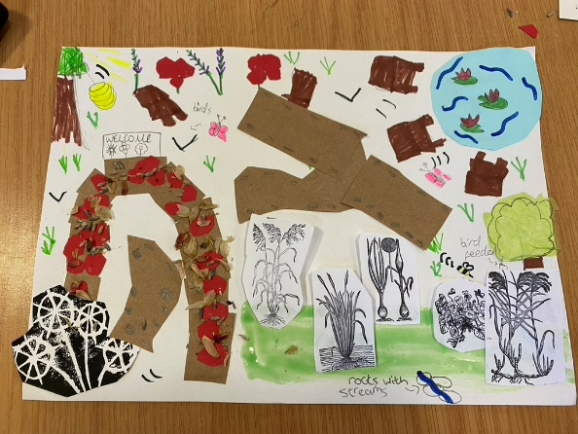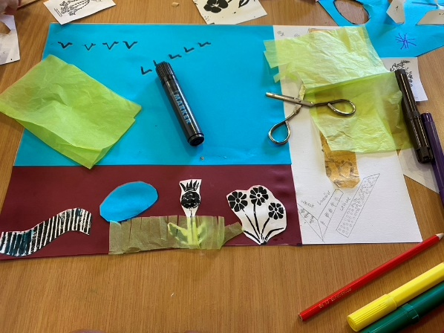

All historical plant images taken from John Gerard’s The Herbal or Generall Historie of Plantes (1597 and 1633)

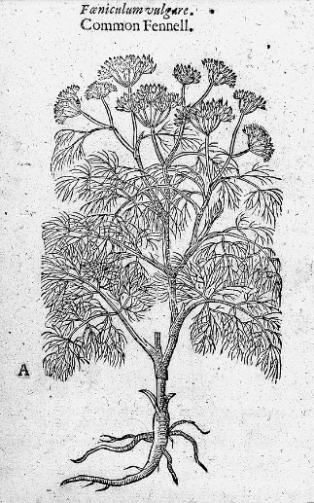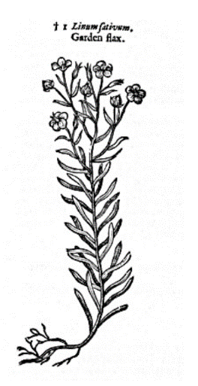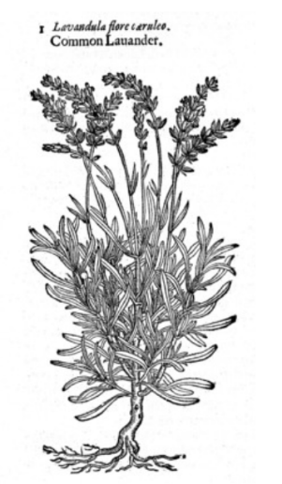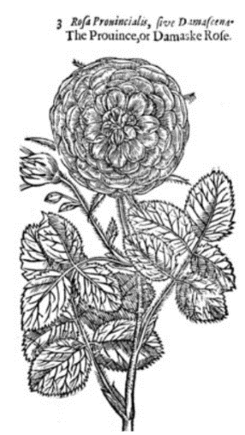

Planning Your Sleep Well Garden: Information to talk through with your class

To ensure good sleep throughout the year, Tudor and Stuart people needed to plan their gardens carefully. They needed plants, vegetables, herbs, and flowers that they could use in lots of different ways to make bedding materials, remedies, foods, and scents to control their bedroom environment, keep themselves healthy, and be ready to sleep well. In the winter, when there wasn’t much growing the garden, a family like the Radclyffes would need to plan what to grow in their gardens and fields for the coming year and where to plant things, as well as have a good stock of supplies they had preserved throughout the spring, summer, and autumn.

The information below will help you decide what you might like to include in your garden collages as you plan the perfect sleep garden. The natural ingredients that could come from the local landscape are underlined.

Bedding Materials:

Blankets and covers helped people in the 16th and 17th century to keep warm or cool in bed, to feel comfortable, and protected during the nighttime. These were all made from materials from nature: flax plants for linen or wool from sheep. Mattress stuffing could be made from duck feathers, straw, and oat chaff [the stems and bits left over after the oats in the fields were harvested]. Other stuffings included moss, wool flock [the wool straight from the sheep rather than spun into thread], and the fluff from things like bullrushes which grow in boggy wetlands. These stuffings would be used alongside herbs that protected against things like bedbugs: lavender and rosemary for example.

Remedies:

Tudor and Stuart sleep remedies included herbs and spices such as rose, lavender, camomile, fennel seeds, and lemon balm. You might want to include these in your sleep garden collages. These helped people to feel relaxed and calm and were believed to bring on sleep. All these ingredients could be dried and then gathered up in a cloth square, tied with string or ribbon, and placed under the pillow. Cooling ingredients like rose and violets could be used in washing waters to cool the head, arms, and legs before bed. Warm herbs like lavender could be used in pot Pourri or heated to clean and warm the air and stop bad smells that were believed caused illness.

Other natural ingredients that could be grown in gardens and used in remedies are listed below. These had different temperatures that worked to heat or cool the body and room depending on whether it was summer or winter:

Cold | Hot
Violets | Valerian
Borage | Lemon balm
Poppies | Cowslips and primroses
Roses | Onions
Lettuce | Fennel and dill
Barley | Lavender
Bullrushes (what the Tudors called ‘cat tails’ | Camomile

All these ingredients worked through the scents they produced, the feelings they caused on the skin, or the effect they had when they were eaten.

Foods and Crops:

Some crops like flax were important for making linen for bedding. The plant was dried out once it had flowered and then the fibres inside the stems were combed and spun on spindles and spinning wheels before being woven into fabric for bedsheets, night gowns and night caps. Flax seeds also appeared in sleep remedies, as with the recipe below.

When crops were harvested, the straw from wheat or ‘chaff’ left behind from oats could be used to stuff mattresses.

Barley could be ground up with seeds like flax or poppy seeds plus milk, rosewater, and vinegar to create a soothing sleep remedy that cooled the head and created sleepy cold smells which relaxed the brain. This mixture would be applied to the head on a cloth, just like the lettuce poultice we make in our Sleeping Well video.



Blundell Hodge Podge
Lancashire Archives Acc 6121 Box 3

To procure sleepe:

Brest milk of a woman [don’t worry, you can used normal milk from the shop], rose water, nuttmeggs, vinegar, linseede, hempseede, barley bread: Boyle all these together in the womans mile then spread them all together upon a rose cake [or mix with dried rose petals] and lay it to your forehead and be hynd of your neck.

Barley could also be used to make barley water which was a cooling drink in the summer. To make it today, boil pearl barley in water, adding your flavourings like lemon and honey, leave for half an hour, strain, and enjoy. There is a recipe card provided as part of these Sleeping Well resources. Barley water could be boiled up with relaxing and sleepy herbs like rose or even lettuce, though you may want to skip that last one

Other sleepy foods pupils might want to consider including in their collage/sleep garden plan include:
- Pears/apples – cooling. The Tudors thought these were dangerously cold and wet in the winter, upsetting their stomachs and making them poorly. In the summer, people thought they were ok to eat, when the weather was warm. If you ate them in the winter, however, you needed to eat them with spices so that they didn’t cool your stomach too much, overwhelm your head with the corrupting gases they produced, and bring bad dreams. Apples and other orchard fruits do appear in Tudor and Stuart sleep remedies as they were cooling.

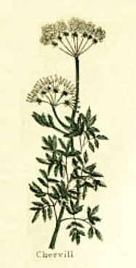
- Warm herbs like chervil and lovage [these warm the stomach and help digestion]. They have pretty white and yellow flowers in the summer and leaves that look like coriander.

- Cucumbers – good for cooling waters to wash your hands and face with in the summer and before bed.

- Onions – it was said that eating raw onions would help you sleep. People who had to stay awake at night, like guards, would eat raw onions in the morning so they could sleep before their nighttime shift.

- Waterlilies – as well as being pleasant to look at, waterlilies were thought to be cooling and so were used in sleep remedies including syrups, oils, and waters. Waterlilies are not considered edible today so please stick to the illustrations!

Gardens for Relaxation and Sleep:
As well as spaces for activities or for looking after animals, calming spaces are also important. An area with some birds so you can hear relaxing bird song might be a good idea. Green spaces could be used for exercise but also for calm reflection and meditation. Gardens are sensory spaces so think about this in your plans. Some water for water lilies and bullrushes to grow in, to use for sleepy remedies or to stuff your pillows, might be combined with a gentle river to create some soothing sounds. You might like a relaxing space to sit in, planted with nice smelling flowers and herbs. Roses and borage were believed to be happy flowers that cheered people up. Your garden should make you feel happy and soothed as well as provide what you needed in the 16th and 17th centuries to help you sleep.

The Decisions You Make:
What you put in your sleepy garden collage is up to you, there are no right and wrong design decisions but bear in mind what would help you to sleep and what you have learned so far about sleep in the past. Think carefully about what you put in the garden and write labels to show why you have included the plants and spaces you have. That way people can see how your garden helps you relax and sleep well.

This image is taken from Nicholas Culpeper’s Complete Herbal (1653)

