Ingredients:
Rose Jam
Fresh rose petals
Sugar
You will also need a pestle and mortar

Gather fresh rose petals and snip off the white bit that connects the petal to the flower head. Put in a pestle and mortar with the same amount of granulated sugar. Grind up until you make a jammy paste. Sterilise a jar or tub with hot water. Put your jam in your container. This will keep well in a cool, dry place. The longer you leave the jam, the rosier it will taste. This is lovely stirred into hot milk or herbal teas or can be added to hot milky puddings. Try making our posset recipe and adding some rose jam to the mix. It can also be used for cake decorating and is nice on hot toast.

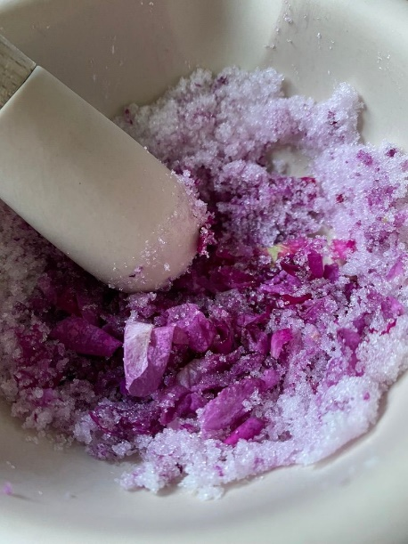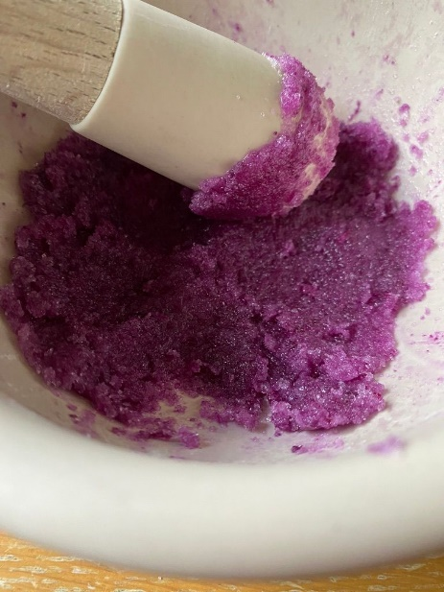

This recipe comes from a cookbook author called Hannah Woolley and was featured in her book The Queen-like Closet (1670). Lots of different flowers could be made into a jam or ‘conserve’ in this way. Another jam with sleep-promoting powers that appears in 16th and 17th century cookbooks was made with violet petals.

Lots of flowers appeared in sleepy recipes which were either preserved with sugar, distilled into cordial waters, or made up into pastes or salves which were applied to the head, often to promote sleep. Washing waters infused with flowers were also used to wash the hands, feet, and face before sleep. Plants that were used to cause sleep included roses, violets, cowslips, borage and camomile and these grow in the gardens here at Ordsall at various times of the year. As these ingredients appeared in gardens throughout the season in the 16th and 17th century, they were preserved in kitchens or in a special room called a ‘still room’. These were spaces which were used mostly by the women of the household for preserving and creating medicines, perfumes, and sweet sugary treats.

Ingredients:
Rose Jam
Fresh rose petals
Sugar
You will also need a pestle and mortar

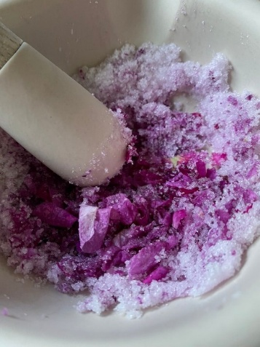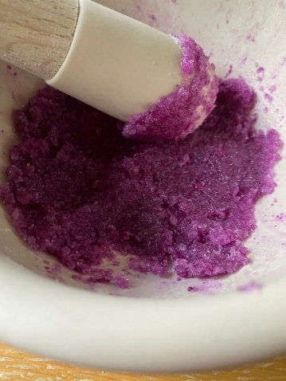

Put in a pestle and mortar with the same amount of granulated sugar. | Sterilise a jar or tub with hot water. Put your jam in your container.
The longer you leave the jam, the rosier it will taste. This is lovely stirred into hot milk or herbal teas or can be added to hot milky puddings. | This will keep well in a cool, dry place.
Gather fresh rose petals and snip off the white bit that connects the petal to the flower head. | Grind up until you make a jammy paste.

