Ingredients:
Posset
3 pints of double cream
8 eggs
A pint of white wine (or apple juice if making a non-alcoholic version)
3 tbsp granulated sugar
1 cinnamon stick (or a tsp ground cinnamon)
½ a grated whole nutmeg (or a tsp ground nutmeg)
(if making the non-alcoholic version you will also need a squeeze of lemon juice)

Heat the cream gently with the cinnamon stick (or ground cinnamon) and grated nutmeg (or ground nutmeg). Once hot, remove the whole cinnamon stick if using. Next, beat the eggs and add to a separate pan with the wine (or juice) and sugar. Gently heat until hot, whisking slowly the whole time. Pour the cream mix into the egg mix, cover, and set aside for an hour to settle. If you are making the non-alcoholic version, you will need to add a squeeze of lemon juice to the mixture to help it to curdle. The posset will be a combination of a creamy custard and curds, similar in taste and feel to a comforting rice pudding.

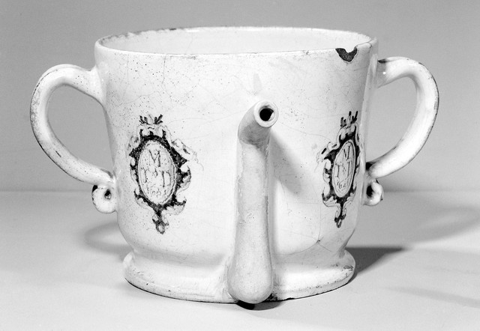
Lambeth delftware posset pot, 1651, Wellcome Collection

Our posset recipe is adapted from a handwritten recipe found in the Folger Library in Washington DC from c.1626 (ref. v.a.456).

Ingredients such as rosewater and hemp seeds, that were believed to cause sleep, were frequently added to posset recipes to help tackle minor illnesses, especially amongst children.

16th century versions were made without sugar, except for a little sprinkled on the top. Later 17th century versions had more sugar and could include whisked egg whites which created layers of curds and froth. Special posset pots were used to serve this layered posset, as shown below.

Ingredients:
Posset
3 pints of double cream
8 eggs
A pint of white wine (or apple juice if making a non-alcoholic version)
3 tbsp granulated sugar
1 cinnamon stick (or a tsp ground cinnamon)
½ a grated whole nutmeg (or a tsp ground nutmeg)
(if making the non-alcoholic version you will also need a squeeze of lemon juice)
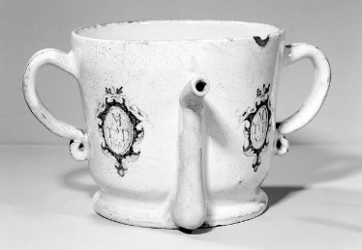
Next, beat the eggs and add to a separate pan with the wine (or juice) and sugar. | Making the non-alcoholic version, you will need to add a squeeze of lemon juice to the mixture to help it to curdle.
The posset will be a combination of a creamy custard and curds, similar in taste and feel to a comforting rice pudding. | Pour the cream mix into the egg mix, cover, and set aside for an hour to settle.
Gently heat until hot, whisking slowly the whole time. | Heat the cream gently with the cinnamon stick (or ground cinnamon) and grated nutmeg (or ground nutmeg). Once hot, remove the whole cinnamon stick if using.
Lambeth delftware posset pot, 1651, Wellcome Collectio

