Ingredients:
Lettuce Poultice

A few lettuce leaves (something with a juicy stalk like cos, iceberg, or romaine is best)
A splash of rosewater
A pinch of ground nutmeg
A splash of milk
You will also need a pestle and mortar and a cloth strip, flannel, or old tea towel

In the pestle and mortar, grind the lettuce (particularly the stalks) until you have some lettuce juice. Add a little rosewater, some milk, and a pinch of ground nutmeg and mix together until you have a paste. Dip your cloth into the mixture or spread a little bit on your cloth. Place this on your forehead.

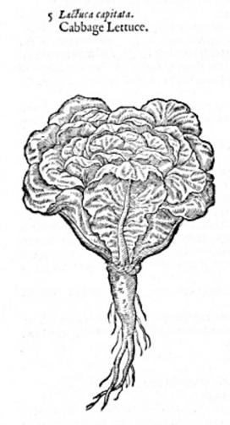
Lettuce illustration from John Gerard’s The Herbal
or General History of Plants (1597)

This remedy has been adapted from one in John Partridge’s The Widowes Treasure (1588), which offered medical advice to female householders. A poultice was a strip of cloth used like a plaster or bandage, onto which a medicinal paste could be spread. A lettuce poultice was most often used to cool the body, and especially the head since lettuce has a high water content. Lettuce poultices had a strong relationship to sleep and were used to ease headaches and fevers in times of illness.

Ingredients:
Lettuce Poultice
A few lettuce leaves (something with a juicy stalk like cos, iceberg, or romaine is best)
A splash of rosewater
A pinch of ground nutmeg
A splash of milk
You will also need a pestle and mortar and a cloth strip, flannel, or old tea towel

Lettuce illustration from John Gerard’s The Herbal
or General History of Plants (1597)

In the pestle and mortar, grind the lettuce (particularly the stalks) until you have some lettuce juice. | Place this on your forehead.
Add a little rosewater, some milk, and a pinch of ground nutmeg. | Dip your cloth into the mixture or spread a little bit on your cloth.
Mix together until you have a paste.

