Ingredients:
Barley Water

75g pearl barley
1.5 litre of water
3 tbsp honey
Juice of two lemons
2 sprigs of lemon balm (if you don’t have any of this you could use fresh mint instead)
You will also need a strainer or muslin/cheesecloth to strain your barley water

First of all, soak your barley for half an hour in cold water. Drain the barley and add 1.5 litres of fresh water. Simmer this for 20 minutes. Once done, turn off the heat and strain to remove the barley. This can be used in salads or soups so don’t throw it away. Add the honey to the barley water with the lemon juice and lemon balm sprigs. Leave to infuse for 20 minutes or until cold.
Best served chilled. Consume the same day.

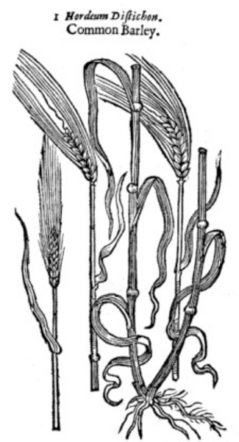
Barley illustration from John Gerard’s
The Herbal or General History of Plants (1597)
Herbal teas are popular today and are a great way to relax in the run up to bedtime. Herbal infusions were also popular in the early modern (Tudor and Stuart) period, particularly those where barley water was combined with various medicinal herbs. These were called ‘ptisanes’.

Barley was thought to be a sleepy ingredient as it cooled the body gently. John Gerard, in his Herbal or garden guide of 1597, recommended adding poppy seeds and lettuce to barley water to ‘provoke sleep’. Both of these ingredients were also cooling and appear in lots of sleep remedies in the period.

Lemon balm also appeared in sleep remedies and was believed to cheer people up and encourage nice dreams.

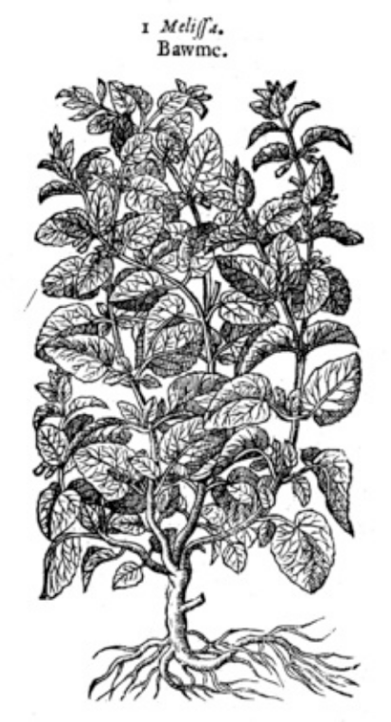
Lemonbalm illustration taken from John Gerard’s
The Herbal or General History of Plants (1597)

Ingredients:
Barley Water
75g pearl barley
1.5 litre of water
3 tbsp honey
Juice of two lemons
2 sprigs of lemon balm (if you don’t have any of this you could use fresh mint instead)
You will also need a strainer or muslin/cheesecloth to strain your barley water

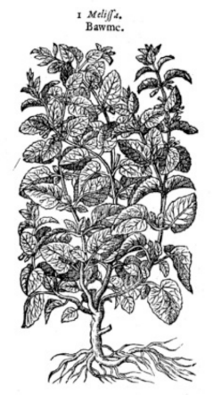 Barley illustration from John Gerard’s
The Herbal or General History of Plants (1597)
First of all, soak your barley for half an hour in cold water. | Once done, turn off the heat and strain to remove the barley. This can be used in salads or soups so don’t throw it away.
Add the honey to the barley water with the lemon juice and lemon balm sprigs. | Best served chilled. Consume the same day.
Leave to infuse for 20 minutes or until cold. | Drain the barley and add 1.5 litres of fresh water. Simmer this for 20 minutes.

