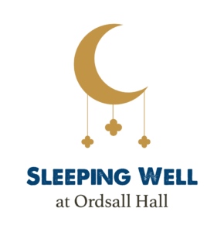
Sleepy Scrapbooks:

Make your own sleepy book using this simple book making technique. Once you have made your book, you can add sleepy images, Tudor sleep tips, recipes, design your own sleep advice book, and/or include pages for your own sleep journal.

Equipment you will need:

- Thick white cartridge paper – 3 A4 sheets per book
- Scissors
- Ribbon – preferably in sleepy pastel colours
- Glue sticks
- The print outs of old botanical from the sleepy collage activity also in these Sleeping Well schools’ resources
- The printable recipe cards from these resources

`Method:

- Start off by folding your A4 sheets in half so you create a smaller book shape.
- Take your scissors and cut three triangles on the side with the fold. One triangle in the top corner, one in the bottom corner, and one in the middle. When you open your book back up, the middle triangle cut will have made a diamond shape.

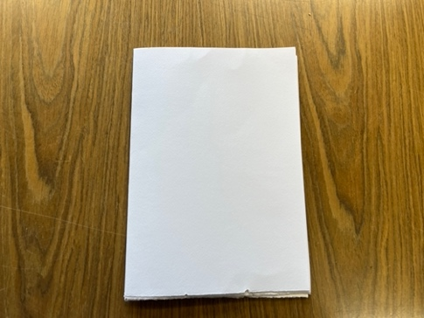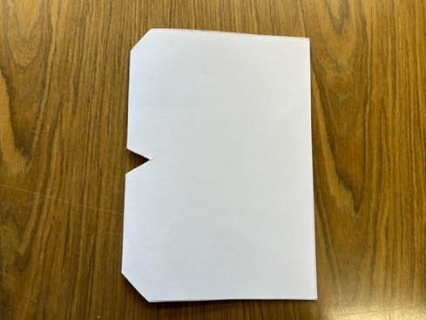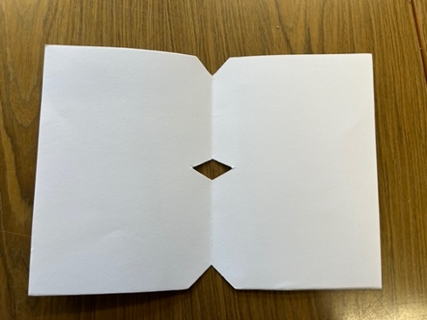

- Take your ribbon. You’ll need roughly 100 cm of ribbon per book.
- Thread your ribbon through the diamond hole from the middle of your book. The ribbon should dangle out of the diamond shape on the outside so that it looks a bit like a snake’s tongue dangling out of its mouth. You’ll want to have about 10 cm dangling through here.

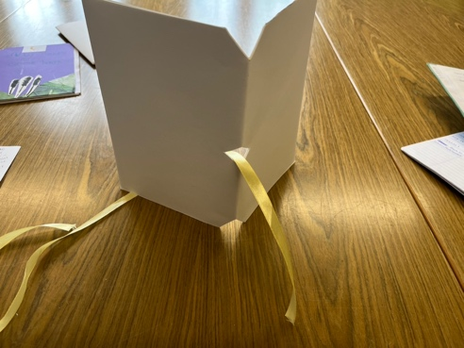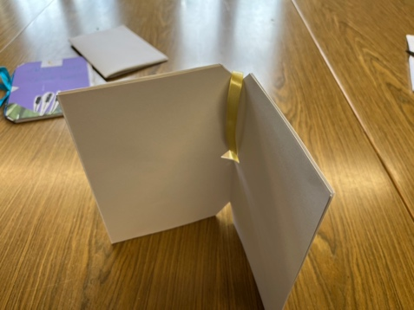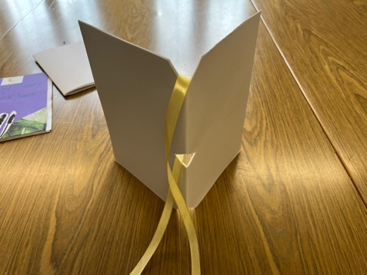

- Take the other end of your ribbon and bring this over the top triangle cut and all the way down the spine of your book. Then bring the ribbon underneath the bottom triangle cut and back up the middle of your book and thread it through the central diamond hole like you did with the other end of the ribbon at the start.

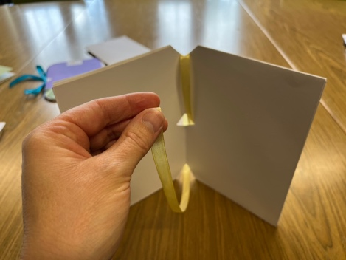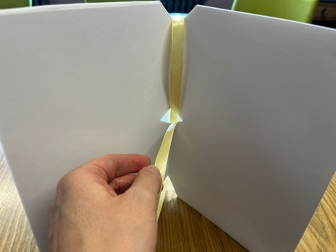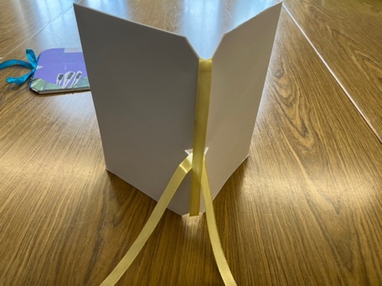

- Your two ends of the ribbon need to go either side of the piece going down the spine.
- Make sure each end of the ribbon is the same length and tie in a bow. Your book is then ready to fill.

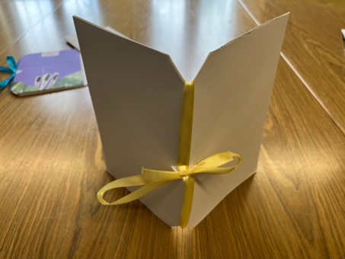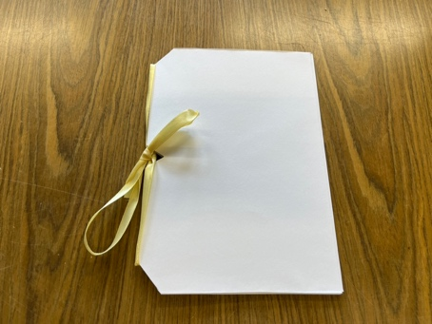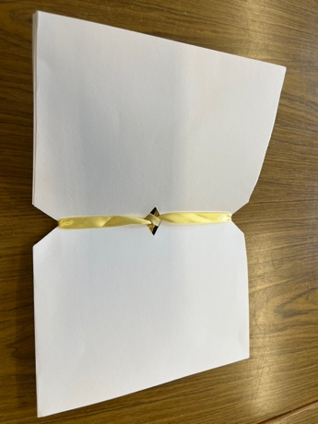

Here are some examples children have created using images, recipes, and early modern sleep advice from our Sleeping Well learning resources plus their own creativity.

A colour cover can be added by substituting the outer white A4 sheet for a coloured piece of card.
